Virginia Grand Assembly
Is sponsoring a fund raising project
To benefit the HVAC project at the Supreme Temple

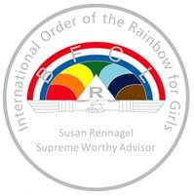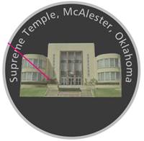

THIS beautiful coin is being produced at no cost
by a very generous Virginia Rainbow Supporter

Please complete the form below and mail your check to him; he will return your products to you. He has already produced about $5,000 for this project!

Name | Address | Phone | Email | Number of Coins | $10 each

Please mail your order and check to:
Mr. John R Marucci
404 White Birch Circle
Columbia, SC 29223-3229

Thank you for your support.
As our historic building ages, retrofitting continues!

