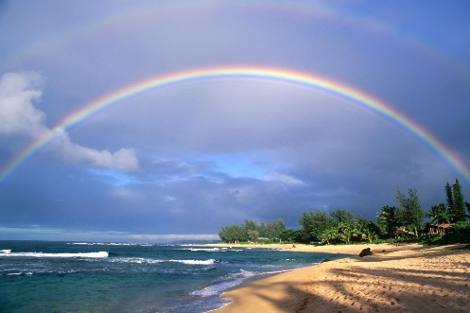
January 31, 2017

Hello Nevada Rainbow –

California Grand Assembly time is here. The “A Stroll Down the Rainbow Beach Boardwalk” Grand Assembly Sessions will be April 7 – 11, 2017 in Fresno, California. We will stay at the Double Tree Hotel for 4 nights and be there from Opening on Saturday until the completion of Installation on Tuesday Afternoon.

ALL REGISTRATIONS ARE DUE TO ME NO LATER THAN FRIDAY FEBRUARY 17, 2017.

The costs for California Grand Assembly include:
- Grand Assembly Registration
- Hotel Housekeeping Gratuity
- Transportation gas expenses
- Special Event on Saturday April 8, 2017 that includes dinner and dessert
- VIP Dinner on Sunday April 9, 2017
- And all additional meals –
Friday April 7, 2017 - Dinner
Saturday April 8, 2017 - Brunch
Sunday April 9, 2017 - Breakfast and Lunch
Monday April 10, 2017 - Breakfast or Grand Cross Banquet, Lunch and Dinner
Tuesday April 11, 2017 - Breakfast, Lunch and Dinner
- If all the money is not spent on meals, it will be spent on snacks, treats, etc. No money collected will go unspent on those attending California Grand Assembly.
The items listed above are a total of $360.00 (at Mrs. Haartz’s request all must be purchased together, no one is to be left behind including both adults and girls)

- Housing at the Double Tree Hotel is $131.04 (including tax) per night for 1 to 4 people per room.

The only other money you will need to bring is your own spending money for souvenirs, etc. We will wear our traveling fabric dresses for most sessions. Grand Officers will wear their 2016 Grand Officers dress for Formal Escort and will need to bring 2 small token gifts – one for their current counterpart and one for their 2017/2018 newly announced counterpart.

TRANSPORTATION – Reno travelers - will travel in a caravan from Reno to Fresno. We will leave from Reno Friday afternoon at 3pm from the McDonalds at Mae Anne and McCarran and will leave for home from Fresno on Tuesday about 4:30pm after the Installation. The travel time between Reno and Fresno is about 6 hours in good weather. Las Vegas travelers – will travel in caravan from Las Vegas to Fresno – travel plans will be done once we know who from Las Vegas is going.

If you are attending, please complete the Registration page and the Transportation/Medical Release form and return to me no later than Friday February 17, 2017. If you have any questions, please do not hesitate to call me at (775) 747-7124 / (775) 233-4204 or email at k.r.butler@sbcglobal.net.
Thank you,
Mrs. Kim Butler
Director of Grand Officers
2017 California Grand Assembly Registration

Name -

Title -

Assembly -

Email address -

Do you have your Grand Cross?

Are you driving to Fresno? If so, how many passengers can you comfortably take including their luggage?

$360.00 = Registration/Transportation gas expenses/Hotel Housekeeping Gratuity/Special Event/VIP Dinner/ALL Meals

Housing at the Radisson Hotel -
$131.04 per person for 4 people in 1 room for 4 nights
$174.72 per person for 3 people in 1 room for 4 nights
$262.08 per person for 2 people in 1 room for 4 nights

FOR adults PLEASE indicate who you would like to room with. FOR Girls you will be assigned rooms. If there are not enough attending to fill the rooms there may be an additional cost. Please remember girls and adults are housed in different rooms.

1.

2.

3.

4.

Total amount due - $
(Make checks payable to Nevada Grand Assembly)

Must be RECEIVED by Friday February 17th

Send payment, this Registration Form and your Transportation / Medical Release form to:
Mrs. Kim Butler – Director of Grand Officers
3247 Barbara Circle
Reno, NV 89503

