The Supreme Temple Committee
Is sponsoring a fund raising project

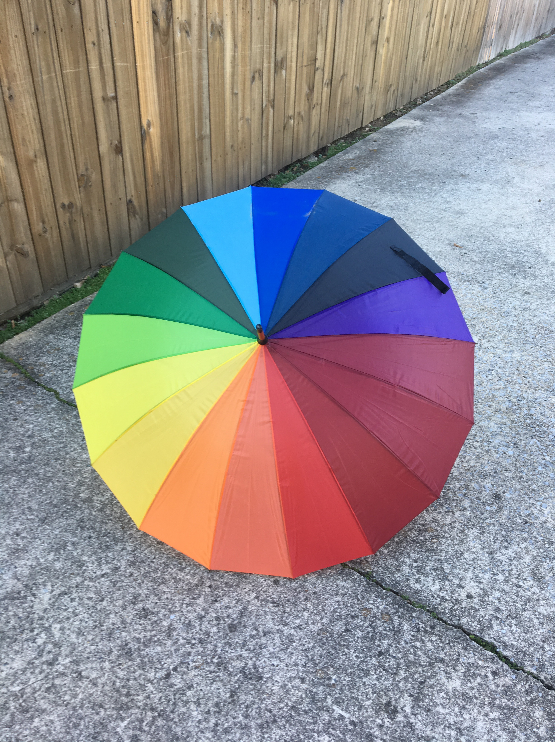

THIS beautiful 48” wooden-handle umbrella is available now!
Proceeds will benefit the Supreme Temple Fund.

If ordered in quantities of 6, they will be shipped free to a single address.
All orders must be processed through the Jurisdiction’s Supreme Officer.

Name | Assembly | Phone | Email | Number of Umbrellas | $20 each

Please mail your order and check payable to NV Grand Assembly to:
Mrs. Heidi Haartz. 11195 Messina Way, Reno, NV 89512

Thank you for your support.
As our historic building ages, retrofitting continues!

