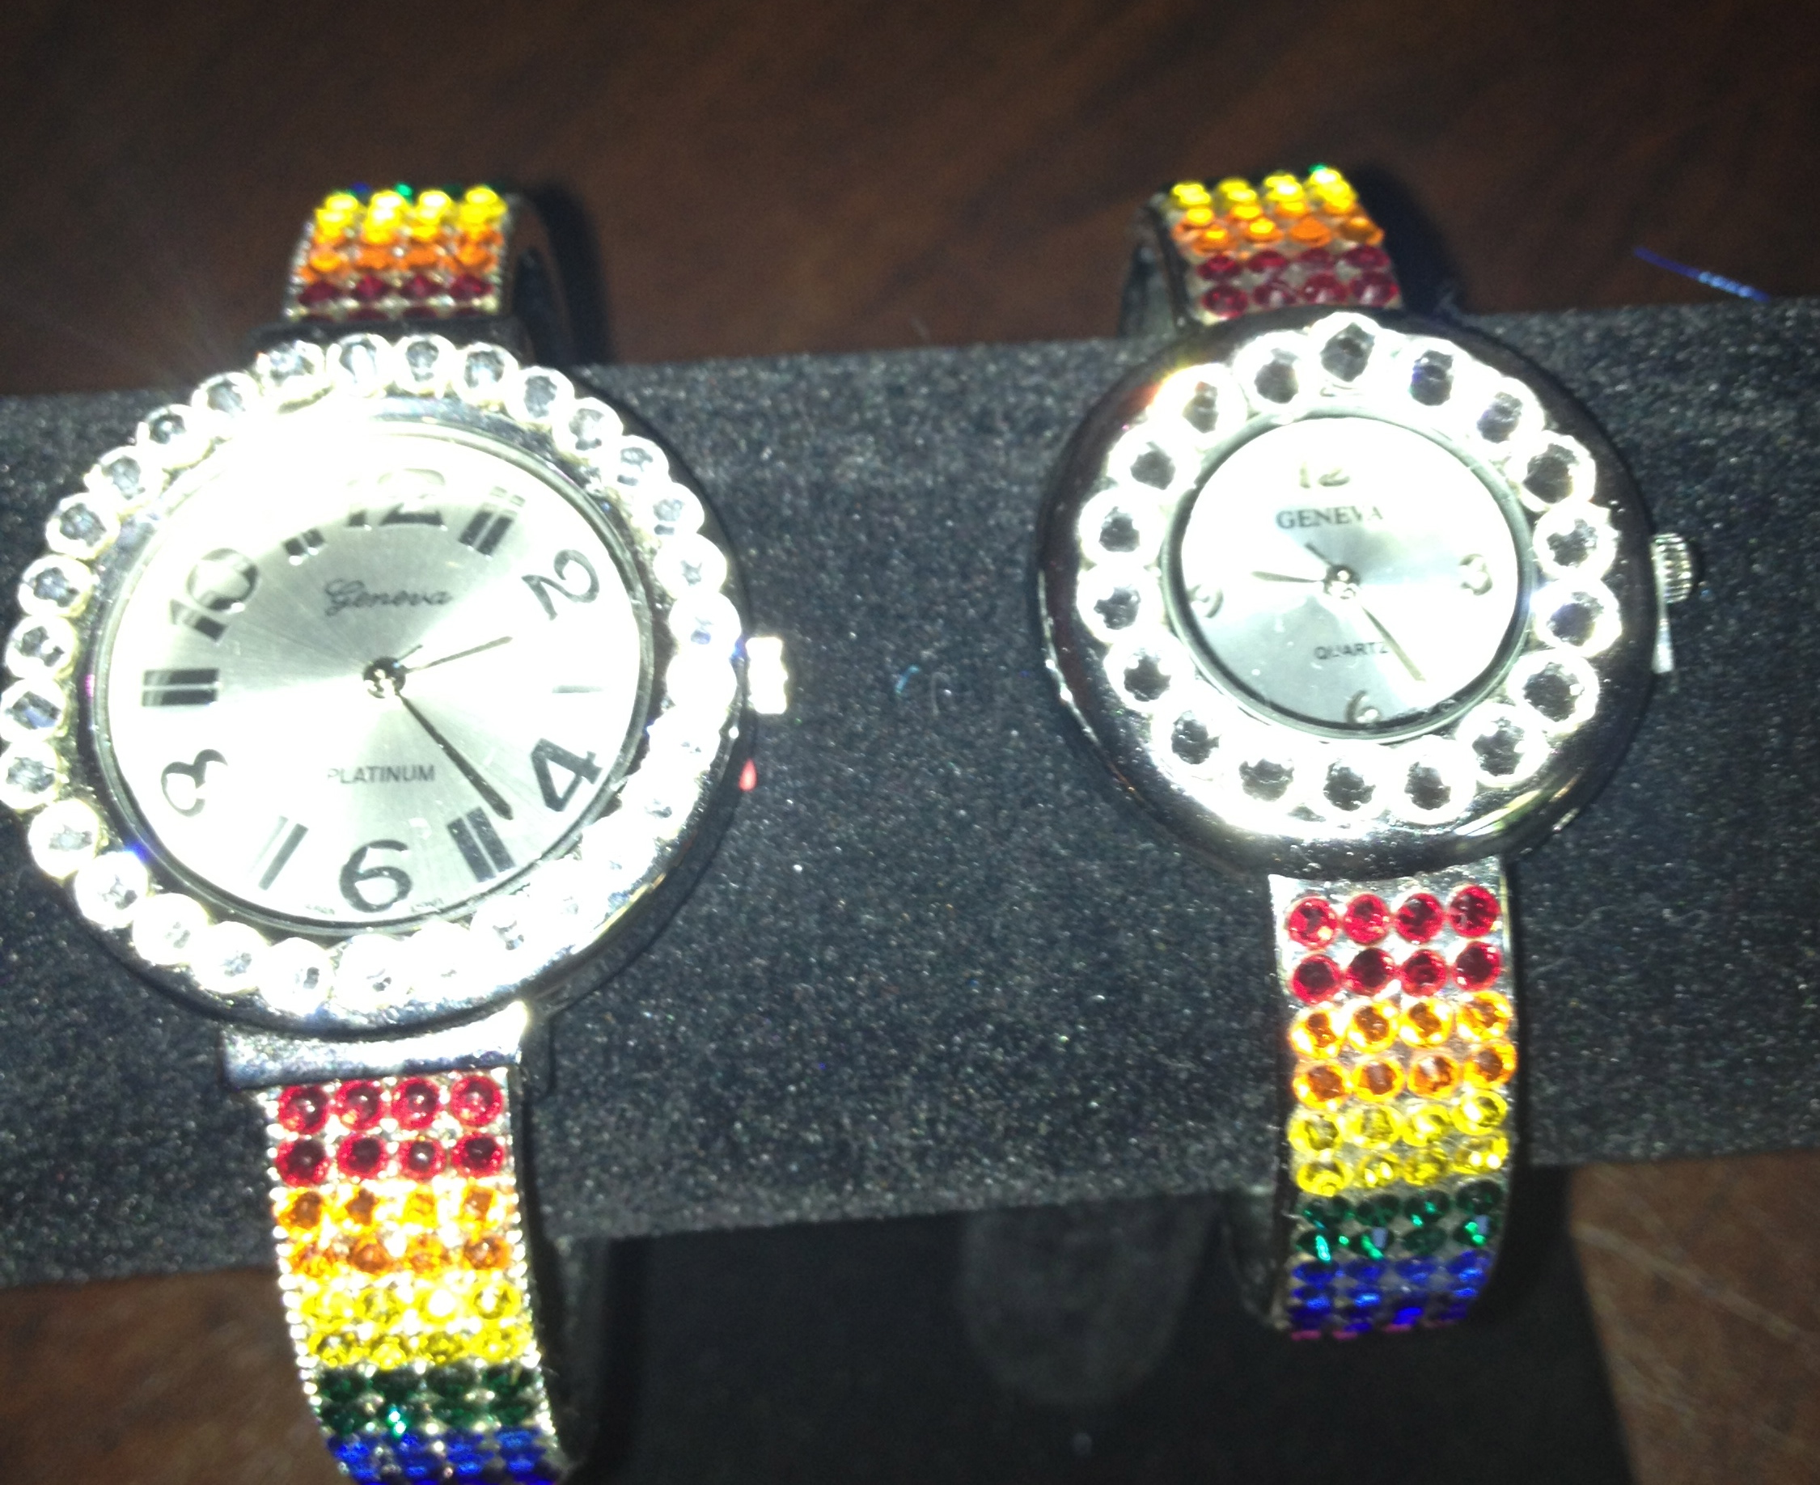

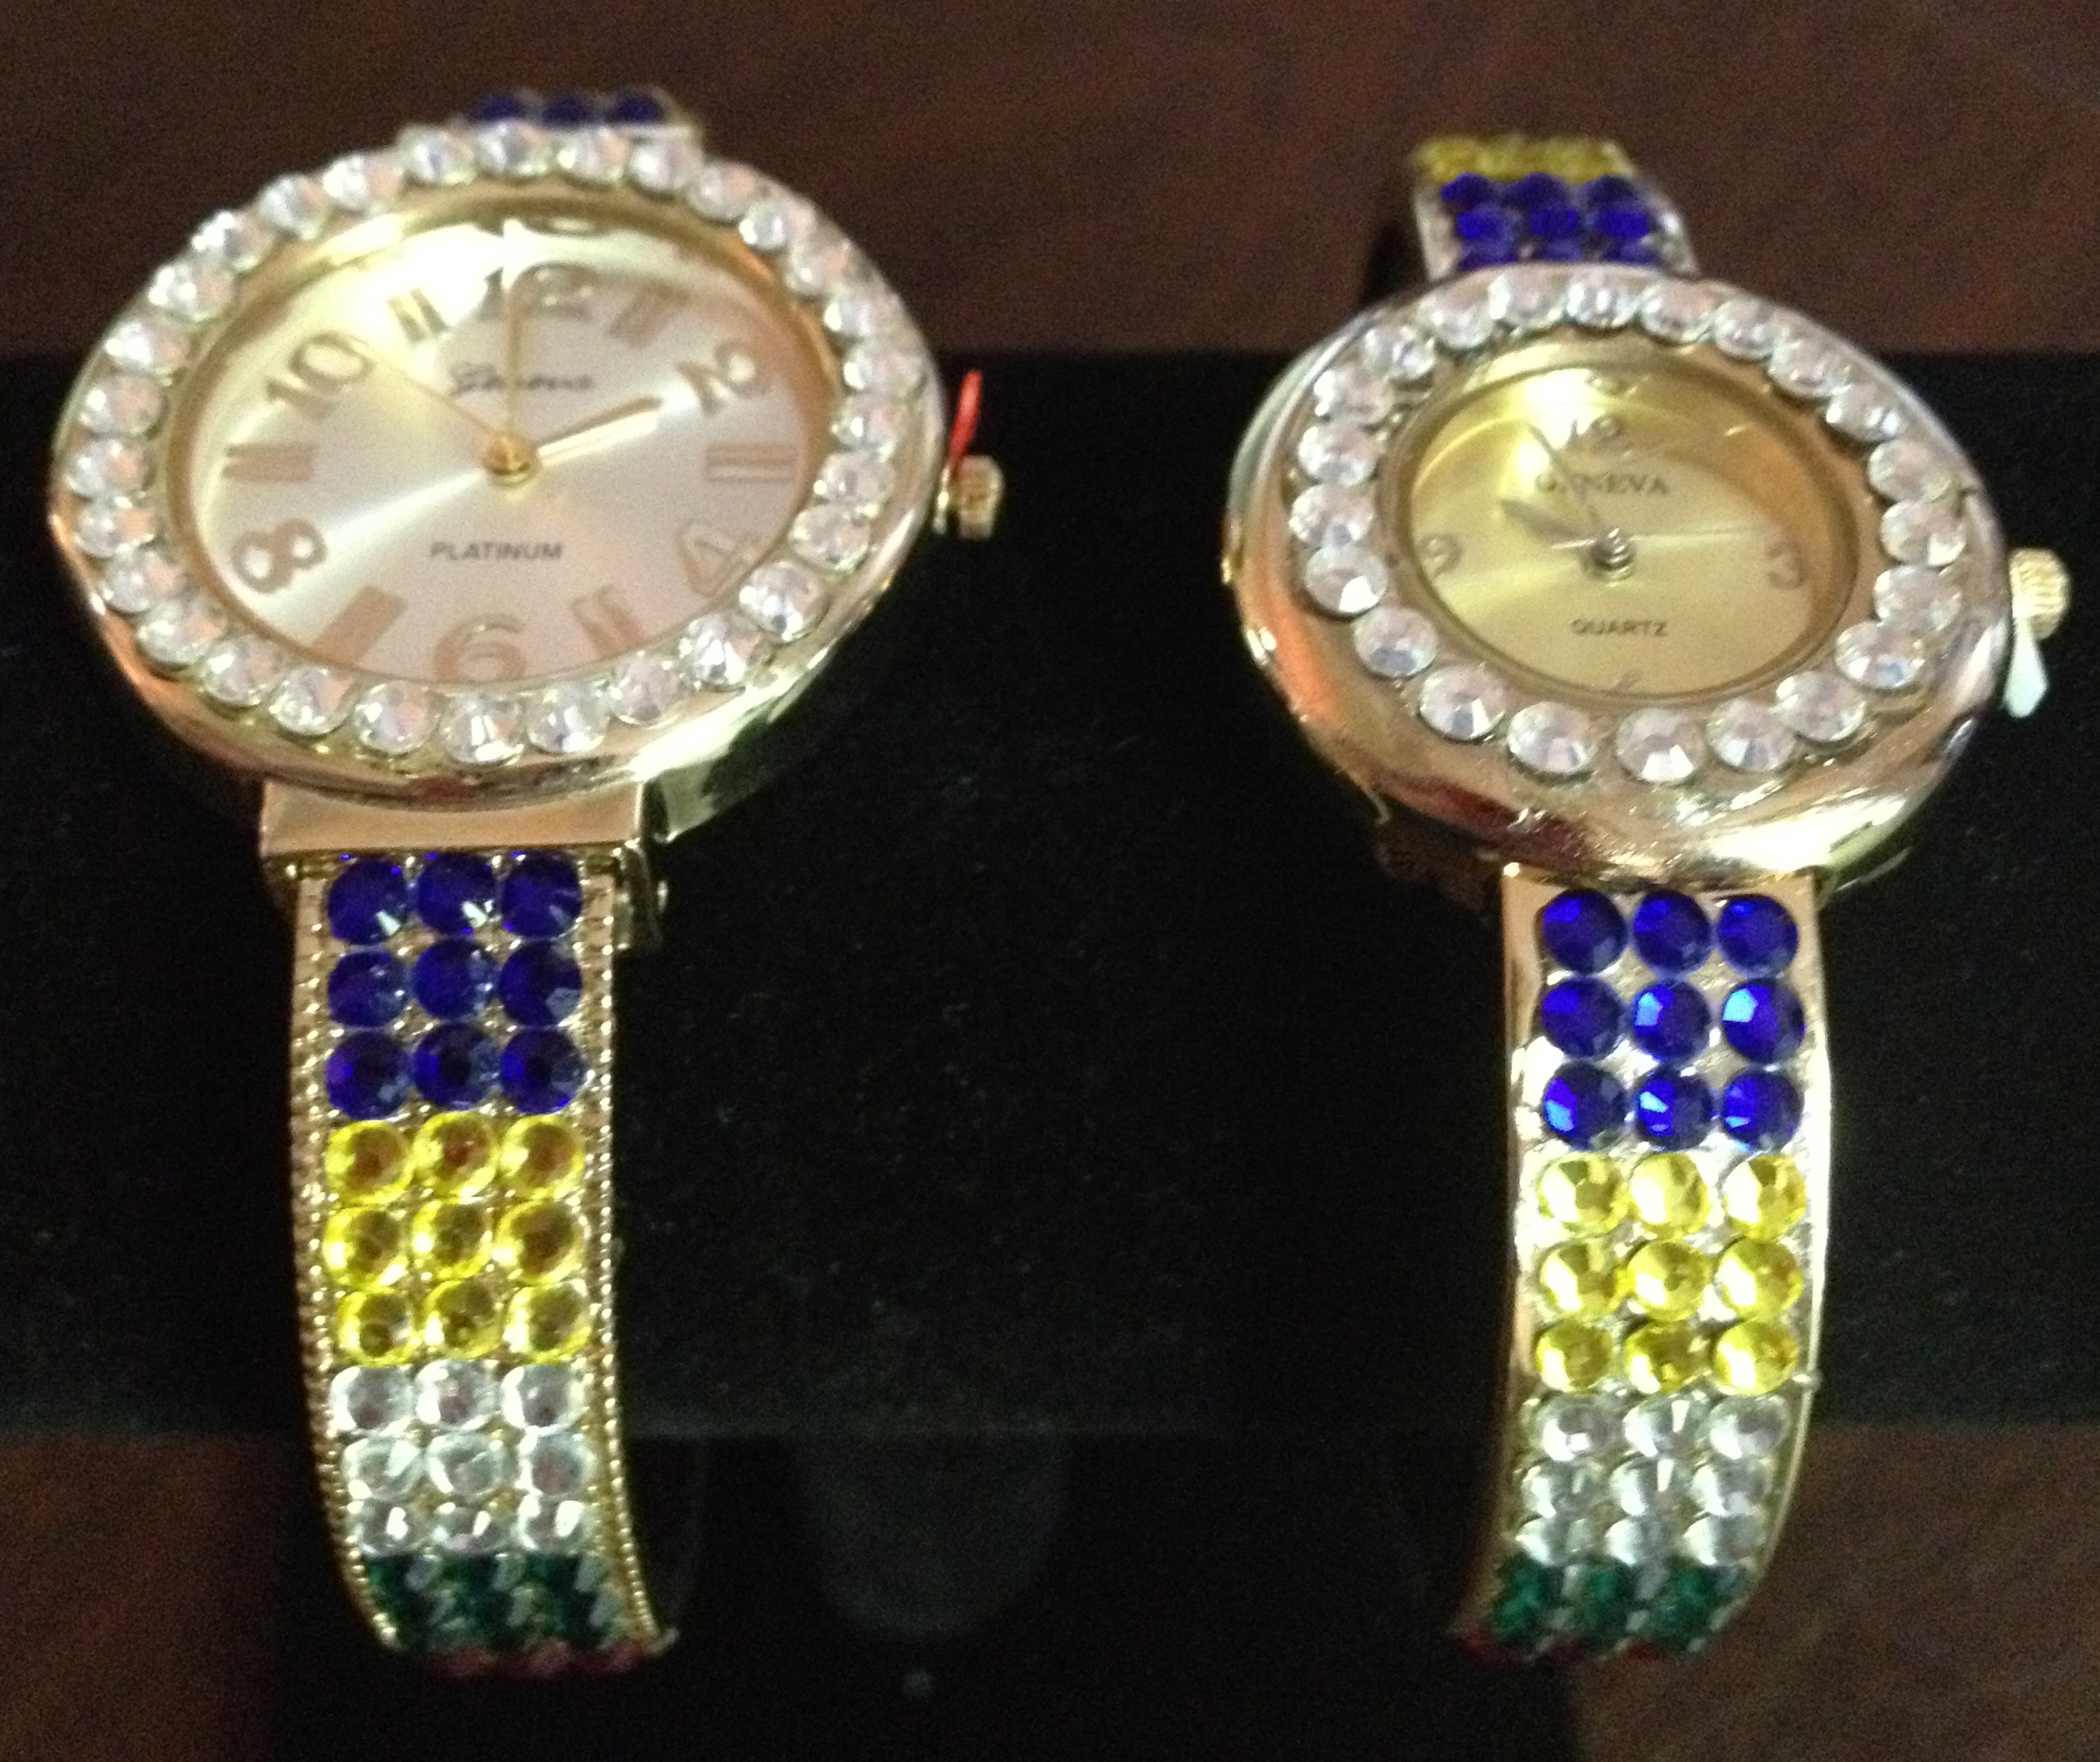
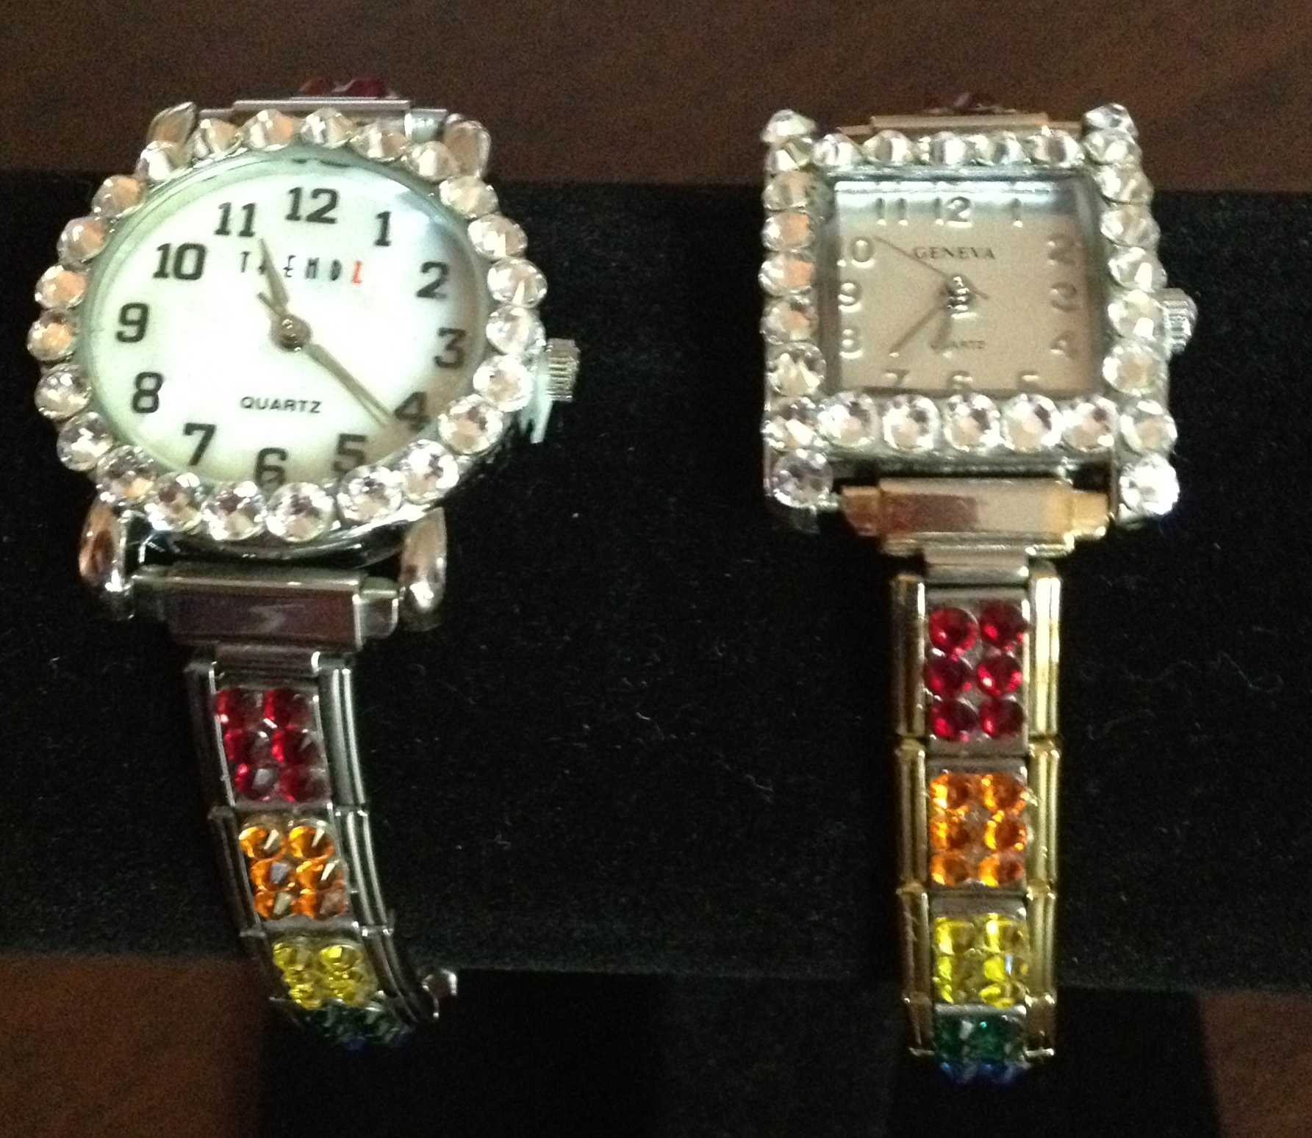

Swarovski Crystal
“Bling” Watches in Rainbow or OES colors
Quantity | Style  Rainbow - OES | Watch Face Size  Large face/small face | Watch Color  Gold, Silver | Price $50 each | TOTAL check - cash
Quantity | Style  Rainbow - OES | Watch Face Size  Round face/Oblong face | Watch Color  Silver or 2-toned Italian Charm style | Price $50 each | TOTAL check - cash

Sold To | Shipping Address if mailing | Phone please include Area Code  EMAIL address

By pre-order only - Crystals are hand set!
Please allow 6 weeks for delivery! *Price includes shipping
Make checks payable to Nevada Grand Assembly, IORG
% Joanie Jacka, Supreme Faith and Supreme Inspector in Nevada
14660 South Quiet Meadow Drive, Reno, Nevada 89511-6674
(775) 853-2288 FAX 853-6336, Cell: 343-8240
jjacka@charter.net

