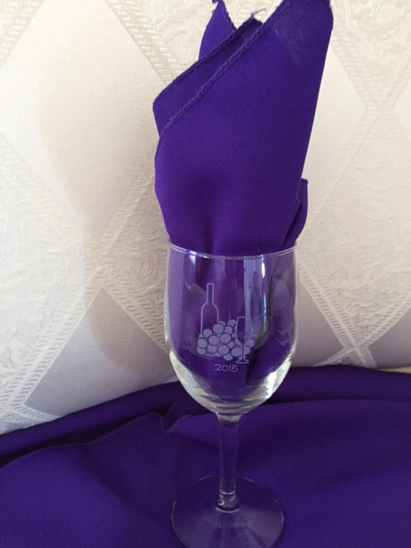

Harvest Moon Gala 2015
Etched Wine Glasses
We have arranged with a local business to have our logo and the year of our event, beginning with 2011 through the current year, etched on commemorative wine glasses.
Orders must be pre-paid and will be available at the Gala.
Please make checks payable to NV Grand Assembly 2020
Mail to: Mrs. Joanie Jacka, 14660 S Quiet Meadow Dr., Reno, NV 89511

Number of Glasses @ $8 each | DATE Etched on the glass with logo | Total Cost | Delivered: (Staff use)  Check Number
 | 2015
 | 2014
 | 2013
 | 2012
 | 2011

Name | Address | City/State | Phone

